**PIZZA Sales SQL queries**

A. KPI’s

1. Total Revenue:

SELECT SUM(total_price) AS Total_revenue from pizza_sales

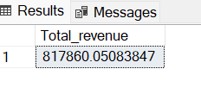

2. Average order value

SELECT SUM(total_price) / COUNT(DISTINCT order_id ) AS Avg_Order_value FROM pizza_sales

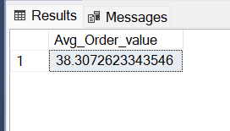

3.Total pizzas sold-

SELECT SUM(quantity) AS Total_sold FROM pizza_sales

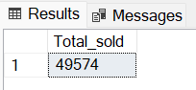

4. Total orders-

SELECT COUNT(DISTINCT order_id) AS Total_orders FROM pizza_sales

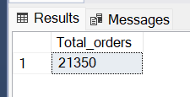

5. Average pizza per order-

SELECT CAST(CAST(SUM(quantity) AS DECIMAL(10,2))/

CAST(COUNT(DISTINCT order_id) AS DECIMAL(10,2)) AS DECIMAL(10,2)) AS Avg_Pizzas_per_rder FROM pizza_sales

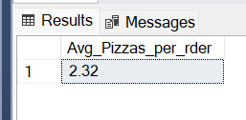

6. Daily trend for total orders

SELECT DATENAME(DW,order_date) as order_day, COUNT(DISTINCT order_id) as Total_orders

From pizza_sales

GROUP BY DATENAME(DW,order_date)

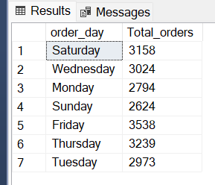

7. Monthly trends for order

SELECT DATENAME(MONTH,order_date) AS Month_name, COUNT(DISTINCT order_id) AS Total_orders

FROM pizza_sales

GROUP BY DATENAME(Month, order_date)

ORDER BY Total_orders DESC

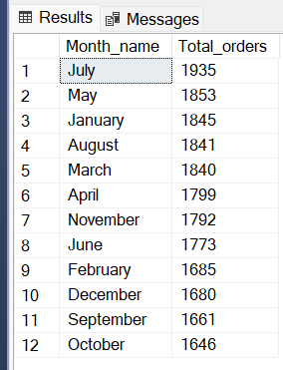

8.% of Sales by Pizza Category

SELECT pizza_category, SUM(total_price)*100/(SELECT SUM(total_price) FROM pizza_sales)

FROM pizza_sales

GROUP BY pizza_category

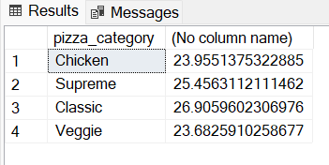

9.% of Sales by pizza size

SELECT pizza_size, CAST(SUM(total_price) AS DECIMAL(10,2)) AS Total_sales, CAST(SUM(total_price)*100/

(SELECT SUM(total_price) FROM pizza_sales WHERE DATEPART(quarter,order_date)=1) AS DECIMAL(10,2)) AS PCT

FROM pizza_sales

WHERE DATEPART(quarter,order_date)=1

GROUP BY pizza_size

ORDER BY PCT DESC

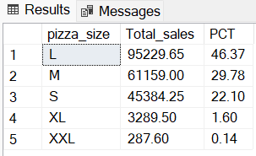

10. Top 5 pizzas

SELECT TOP 5 pizza_name, SUM(total_price) AS Total_revenue FROM pizza_sales

GROUP BY pizza_name

ORDER BY Total_revenue DESC

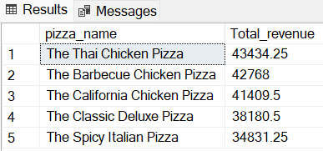

11. Bottom 5 pizzas

SELECT TOP 5 pizza_name, SUM(total_price) AS Total_revenue FROM pizza_sales

GROUP BY pizza_name

ORDER BY Total_revenue

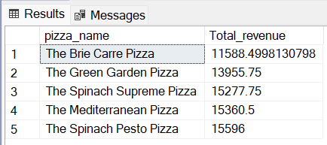

12.Top 5 by pizza quantity

SELECT TOP 5 pizza_name, SUM(quantity) AS Total_Quantity FROM pizza_sales

GROUP BY pizza_name

ORDER BY Total_Quantity

